**Standard Paint Colors**

**Blue**  **Red**  **Sage Green**

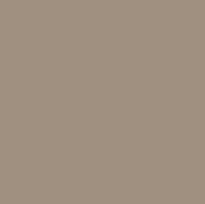

**Navajo White** **White**  **Oyster Shell**

  

**Blue Bows** **Classic Burgundy** **Flagstone Gray**

 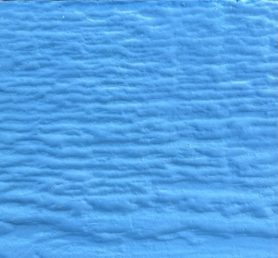

**Black Blue Gray Teal**

**Urethane Paint Colors**

**Chestnut Urethane** **Driftwood Urethane**

**Cedar Urethane** **Honey Gold Urethane**

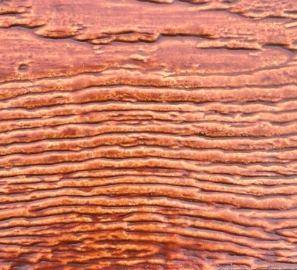

**Redwood Urethane**